Mongo Database
Tristan
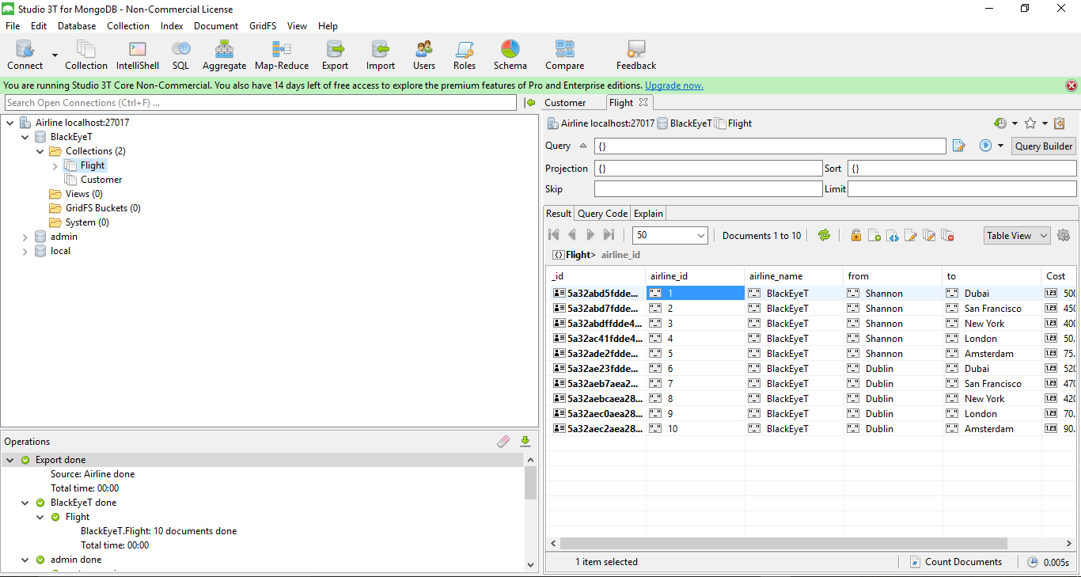
Figure 6 Studio 3T to create and export database

Java Runtime Analysis Tool
Tristan

